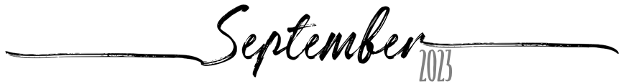

Sunday | Monday | Tuesday | Wednesday | Thursday | Friday | Saturday
27 | 28 | 29 | 30 | 31 | 1 | 2
3 | 4 | 5 | 6 | 7 | 8 | 9
10 | 11 | 12 | 13 | 14 | 15 | 16
17 | 18 | 19 | 20 | 21 | 22 | 23
24 | 25 | 26 | 27 | 28 | 29 | 30
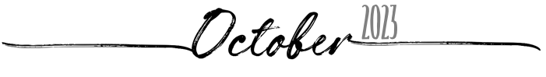

Sunday | Monday | Tuesday | Wednesday | Thursday | Friday | Saturday
1 | 2 | 3 | 4 | 5 | 6 | 7
8 | 9 | 10 | 11 | 12 | 13 | 14
15 | 16 | 17 | 18 | 19 | 20 | 21
22 | 23 | 24 | 25 | 26 | 27 | 28
29 | 30 | 31 | 1 | 2 | 3 | 4

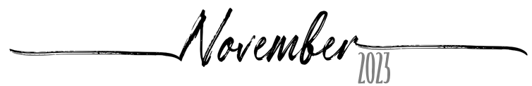

Sunday | Monday | Tuesday | Wednesday | Thursday | Friday | Saturday
29 | 30 | 31 | 1 | 2 | 3 | 4
5 | 6 | 7 | 8 | 9 | 10 | 11
12 | 13 | 14 | 15 | 16 | 17 | 18
19 | 20 | 21 | 22 | 23 | 24 | 25
26 | 27 | 28 | 29 | 30 | 1 | 2

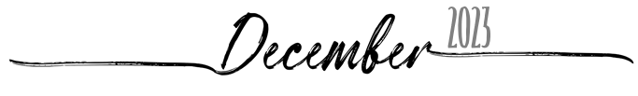

Sunday | Monday | Tuesday | Wednesday | Thursday | Friday | Saturday
26 | 27 | 28 | 29 | 30 | 1 | 2
3 | 4 | 5 | 6 | 7 | 8 | 9
10 | 11 | 12 | 13 | 14 | 15 | 16
17 | 18 | 19 | 20 | 21 | 22 | 23
24 | 25 | 26 | 27 | 28 | 29 | 30
31 | 1 | 2 | 3 | 4 | 5 | 6

